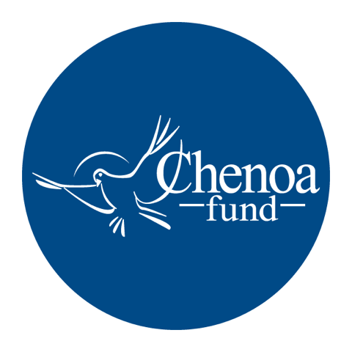

Who wrote the article. This article was written by CBC Mortgage Agency (https://chenoafund.org) staff writers for the purpose of helping homebuyers learn about the mortgage industry, down payment assistance, and related topics.

Who owns the copyright. Copyright © CBC Mortgage Agency. All right reserved.

Directions for reuse. You have permission to use this article in print and electronically media (e.g., blogs, newsletters, websites, podcasts) for commercial and non-commercial use as long it is passed along unchanged and in whole, with credit to Chenoa Fund.

Article begins on next page.

Article Title: Homebuying Simplified: Choosing a Down Payment Assistance Program

You’ve reached that magical point in life. You’ve got a solid job with a stable income, a good credit score, limited debt, and plans to sink roots in your community. In short, you’re ready to become a homeowner, except for one thing – the down payment.

If that scenario sounds eerily familiar, take heart. For starters, you’re not alone. And secondly, there’s help out there for folks like you.

Down payment assistance, or DPA, is a tool designed to help credit-worthy borrowers meet their up-front cash obligation and secure a mortgage. In recent years, DPA has become an increasingly significant part of affordable homeownership programs offered by state Housing Finance Agencies, local governments and nonprofit organizations.

Before you start looking for a DPA program that suits your needs, ask yourself a few questions. Finances are one key area. Are you definitely ready to take on a mortgage? Failing to make a loan payment is not like missing a month or two of rent and trying to keep the landlord calm. Lenders expect on-time payments, and there are costly consequences – potentially leading to foreclosure – for falling behind.

If the economics look good, take stock of your employment situation. Make sure you’re not planning a job change any time soon, nor facing a possible transfer. Buying a home is a commitment, and having to sell a house quickly is no fun – and a potential money loser.

Assuming all systems are go, it’s time to explore the DPA possibilities that best fit your situation. Lenders are one good resource, and friends and colleagues who have recently purchased homes can often steer you in a promising direction.

Online, help can be found at Down Payment Resource, through multiple sites created by lenders and the real estate industry professionals, and through state Housing Finance Agencies, which can be accessed here. FreddieMac also has a borrower help center that can provide useful advice.

DPA usually is provided in the form of a grant or, more commonly, a second mortgage. The second mortgages often have a zero or low interest rate, allow for deferred repayment or may be entirely forgiven over time.

Your personal circumstances and long-term plans largely dictate which approach you should take. Borrowers who intend to remain in their home for many years, for example, would benefit from a first mortgage with a low interest rate and DPA assistance through a repayable second mortgage.

On the other hand, for buyers who plan to stay in their homes only a few years before moving up to something bigger and better, a forgivable down payment coupled with a higher interest rate on the first mortgage likely makes more sense.

At our organization, the CBC Mortgage Agency, we offer several DPA options to borrowers on a national scale under the umbrella of the Chenoa Fund:

DPA Edge Program: With this program, borrowers receive a 30-year term, 0% rate, no payment second mortgage. Borrowers must meet a minimum FICO score of 620 and report a qualifying income that is equal to or below 115% of the median income for the county in which they will live. The loan is forgiven once the borrower makes 36 consecutive on-time payments on the original FHA first mortgage.

Chenoa Fund Repayable Second Program: This program carries no income restrictions and offers two options for a repayable second mortgage – a 10-year repayable second at 0% interest rate or a 30-year repayable second at 5% interest rate. Borrowers must meet a minimum FICO score of 620.

Rate Advantage Program: This alternative allows borrowers to lock in their first mortgage at a market comparable rate. Borrowers must meet a minimum FICO score of 620, have a debt-to-income ratio of 50% or less, and have a qualifying income equal to or less than 115% of the median income for the county in which they will live. The down payment assistance is repaid over a 10-year period at 8%.

Whatever path you choose, we offer our encouragement as you make the transition from renter to homeowner. Studies consistently document the many social and economic benefits of homeownership, from family stability to improved psychological health and higher rates of high school and college completion.

Here’s hoping your hard-earned dollars will soon be paying the mortgage, not rent.

Source: Chenoa Fund, https://chenoafund.org
The Chenoa Fund is an affordable housing program administered by CBC Mortgage Agency (CBCMA), a federally chartered governmental entity. CBCMA specializes in providing down payment assistance financing under FHA and conventional guidelines.

