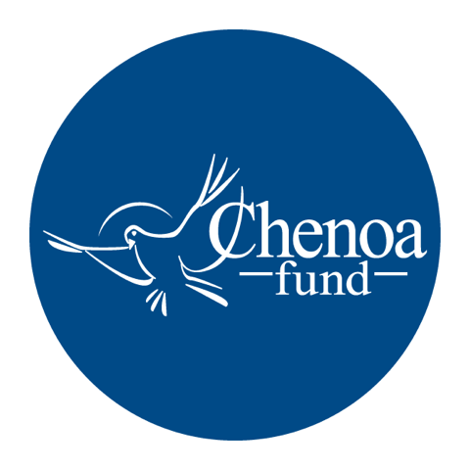

Who wrote the article. This article was written by CBC Mortgage Agency (https://chenoafund.org) staff writers for the purpose of helping homebuyers learn about the mortgage industry, down payment assistance, and related topics.

Who owns the copyright. Copyright © CBC Mortgage Agency. All right reserved.

Directions for reuse. You have permission to use this article in print and electronically media (e.g., blogs, newsletters, websites, podcasts) for commercial and non-commercial use as long it is passed along unchanged and in whole, with credit to Chenoa Fund.

Article begins on next page.

Article Title: Down Payment Assistance Programs for First-time Homeowners

Down payment assistance (DPA) programs provide cash to low-income homebuyers who can’t make the down payment or pay closing costs involved in obtaining a mortgage. Typically, DPA programs are offered by federal, state, and local government agencies, as well as by nonprofit organizations or employers.

The benefits of DPA include 0% interest rates, deferred payments, and forgivable loans. The amounts available to buyers can range as high as tens of thousands of dollars that can be applied toward a down payment, closing costs, principal reductions, and repairs.

Program guidelines can vary, but in most cases, applicants must:
- Be a first-time homebuyer, defined as someone who hasn't owned a home in the last three years
- Occupy the property as your primary residence
- Complete homebuyer education counseling and obtain a certificate of completion through an eligible homebuyer counseling organization
- Meet the requirements of the lender and the mortgage insurer/guarantor
- Have a household income that falls within program limits
- Purchase a home with a price that falls within program limits

Below are descriptions of some of the most common forms of down payment assistance.

Soft Second
A soft second mortgage combines a subsidized second mortgage with a traditional first mortgage to make housing more affordable for low- and middle-income homebuyers. There are usually income restrictions limiting who is eligible.

One example is the Chenoa Fund Edge Program. With this program, the borrower receives a 30-year term, 0% rate, no payment, second mortgage. Borrowers must meet a minimum FICO score of 620 and have a qualifying income equal or less than 115% of the median income for the county in which the borrower will live. The loan is forgiven as soon as the borrower makes 36 consecutive on-time payments on the FHA first mortgage.

Repayable Second
Repayable down payment assistance programs provide buyers with the down payment they need now so they can buy a home sooner. The funds are delivered at closing, often as a 0% interest second loan, but some may accrue interest and some may be amortizing loans. Programs typically include 5-year to 30-year loans, with varying repayment terms. The Chenoa Fund Edge Repayable Second program has no income restrictions for buyers, and offers two options for a repayable second. The borrower can choose a 10-year repayable second at 0% interest rate or a 30-year repayable second at 5% interest rate. Borrowers must meet a minimum FICO score of 620.

State and Local Grants and Programs
In addition to programs provided by the federal government, many states and local governments offer help to first-time homebuyers. Local housing agencies — county or city — are also a useful resource. Community grant programs can often provide the best deals for low- to moderate-income homebuyers. These programs are designed to encourage more people to buy and settle in their city limits.

Check your state’s or community’s website for information on housing grants and programs available in your area.

Employer Mortgage Assistance
Some employers provide their employees with mortgage assistance programs in a variety of forms. They include grants, a direct, fully repayable second mortgage or unsecured loan, a forgivable second mortgage or unsecured loan, and a deferred-payment second mortgage or unsecured loan.

A borrower may use these funds to covers all or part of the down payment or closing costs subject to the minimum borrower contribution requirements. Employer assistance funds are not allowed on a second home or an investment property.

Source: Chenoa Fund, https://chenoafund.org
The Chenoa Fund is an affordable housing program administered by CBC Mortgage Agency (CBCMA), a federally chartered governmental entity. CBCMA specializes in providing down payment assistance financing under FHA and conventional guidelines.

