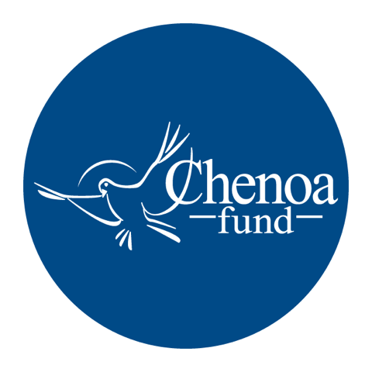

Who wrote the article. This article was written by CBC Mortgage Agency (https://chenoafund.org) staff writers for the purpose of helping homebuyers learn about the mortgage industry, down payment assistance, and related topics.

Who owns the copyright. Copyright © CBC Mortgage Agency. All right reserved.

Directions for reuse. You have permission to use this article in print and electronically media (e.g., blogs, newsletters, websites, podcasts) for commercial and non-commercial use as long it is passed along unchanged and in whole, with credit to Chenoa Fund.

Article begins on next page.

Article Title: Should I Rent or Should I Buy?

If you’re a renter, the odds are you’ve dreamed about buying your own home. Surveys show that a large majority of adults view buying a house as a key piece of the American Dream, and hope to someday trade their rent check for a mortgage payment.

But deciding when or whether to make the leap can be tricky – and deserves some serious soul searching. For the most part, the question is one of economics. Are you financially prepared to buy a home? Or is renting still the best option?

The advantages of renting can be summed up pretty quickly. Occupying someone else’s home typically means you aren’t responsible for maintenance costs, you don’t need to worry about falling real estate values, you are spared the annual pain of property taxes, and you can relocate with relative ease.

While some of those pluses are attractive, consider the downsides. First, a renter’s choices are limited by what’s available, and in competitive markets, it can be hard to find a home that suits one’s needs. Renters also have little or no control over the appearance and condition of their home – inside and out – and most landlords have little motivation to make significant upgrades for their tenants.

Once you sign a lease, you’re legally bound to remain in the rental for the term of the contract – or face hefty penalties for moving out early. That means if the traffic noise is too loud or the neighbor’s barking dog is driving you crazy, you’re pretty much stuck until your lease is up.

The most significant disadvantages renters face, however, are financial. For starters, renting does not build equity, so each month’s payment is just that – a payment, not an investment in your future. In addition, renting does nothing to enhance your credit score. In terms of taxes, rent is not deductible, so you get no break there. And finally, anyone who has ever been a tenant can agree on one unavoidable truth – the rent always goes up.

By contrast, owning a home means paying a mortgage that is much more predictable – or totally predictable if your mortgage is at a fixed rate. This eliminates financial uncertainty that not only adds stress to your life, but makes it hard to plan for future investments.

The biggest bonus that comes from owning your own home is the chance to build equity. As your house increases in value over time, your investment is steadily enhanced, creating a sense of stability that, studies show, leads to improved health outcomes and other family benefits.

Owning a home also brings tax breaks, the chance to strengthen your credit history, and freedom from landlords. When you own a home, you are king or queen of the castle, and you can decide what type of fence to build, what color to paint the kitchen, and whether you want a cat (or four of them).

You also control your own destiny when you own your home, and your family can sink roots, develop long-lasting relationships and ensure children have stable friendships and can spend multiple years in the same school.

Are there disadvantages to owning? Of course. You’ll need to set aside funds for home repairs or remodeling, and purchasing a home requires a fair amount of effort, money and paperwork up front.

To decide which route is best for you, make your own, personalized pro and con list. Whatever decision you make, the key is to evaluate your situation honestly and base your choice on facts.

Source: Chenoa Fund, https://chenoafund.org
The Chenoa Fund is an affordable housing program administered by CBC Mortgage Agency (CBCMA), a federally chartered governmental entity. CBCMA specializes in providing down payment assistance financing under FHA and conventional guidelines.

