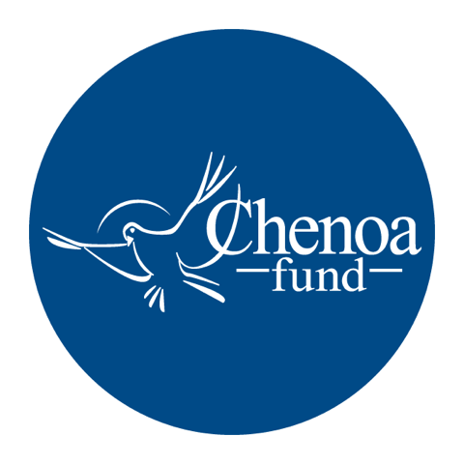

Who wrote the article. This article was written by CBC Mortgage Agency (https://chenoafund.org) staff writers for the purpose of helping homebuyers learn about the mortgage industry, down payment assistance, and related topics.

Who owns the copyright. Copyright © CBC Mortgage Agency. All right reserved.

Directions for reuse. You have permission to use this article in print and electronically media (e.g., blogs, newsletters, websites, podcasts) for commercial and non-commercial use as long it is passed along unchanged and in whole, with credit to Chenoa Fund.

Article begins on next page.

Article Title: Mistakes to Avoid after You’re Pre-approved

One of the most critical steps in the homebuying process is becoming “pre-approved” or “pre-qualified” for a home loan. Once you hit this milestone, it’s tempting to throw a party and start shopping for a new living room set. But be forewarned: complications can arise.

To ensure you enjoy smooth sailing all the way to your closing date, it pays to take pains to avoid certain actions that can raise red flags with lenders and throw a hitch in your best-laid plans.

Most of these “don’ts” relate, not surprisingly, to your finances. If you have other loans, for example, it’s critical that you don’t miss a payment. Similarly, refrain from consolidating your debt, shifting to a new bank, or making any large deposits or cash deposits at your financial institution. Showing stability is the key, so don’t move your investments or finances around before your loan is formally approved.

As for your credit, it’s important to maintain the status quo there as well. Do not apply for new credit cards or purchase any large items, such as appliances or furniture, on credit. In addition, do not close any credit accounts or – and this is a common mistake – make any inquiries about your credit score.

There are several other moves to avoid, and while they may seem obvious, they frequently pose snags for homebuyers in the final stretch. One is changing jobs, which can unsettle lenders seeking reassurance that you’ll have a steady, ongoing income to make mortgage payments.

Another is purchasing a car, a big ticket item that will be a competing monthly financial obligation. Some people also get in trouble when they co-sign a loan for a friend or relative, so it’s best to avoid that until you’ve closed on your home.

As the purchase process continues, you’re likely to get frequent requests from your lender, often for additional documents. Don’t ignore these! Complying quickly will keep the ball traveling toward the goal line – and your move-in date.

Finally, don’t forget to protect that money you’ve carefully accumulated for closing costs and a down payment. Without it, even the best real estate agent can’t get you the keys to your new home.

Source: Chenoa Fund, https://chenoafund.org
The Chenoa Fund is an affordable housing program administered by CBC Mortgage Agency (CBCMA), a federally chartered governmental entity. CBCMA specializes in providing down payment assistance financing under FHA and conventional guidelines.

