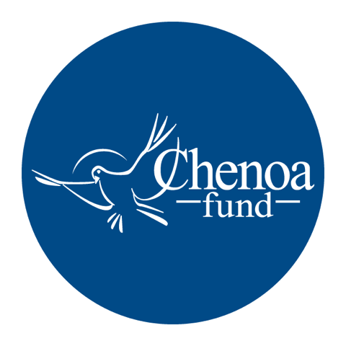

Who wrote the article. This article was written by CBC Mortgage Agency (https://chenoafund.org) staff writers for the purpose of helping homebuyers learn about the mortgage industry, down payment assistance, and related topics.

Who owns the copyright. Copyright © CBC Mortgage Agency. All right reserved.

Directions for reuse. You have permission to use this article in print and electronically media (e.g., blogs, newsletters, websites, podcasts) for commercial and non-commercial use as long it is passed along unchanged and in whole, with credit to Chenoa Fund.

Article begins on next page.

Article Title: Debunking Homebuyer Down Payment Myths

Of all the barriers blocking people from becoming homeowners, one stands out above the rest: the down payment. For many young or low-to-median-income Americans, the prospect of accumulating a big chunk of cash to put down on a home seems virtually impossible – especially if they lack family members able to give or loan them some or all of the funds.

Surveys consistently show that most renters cite “affording the down payment” as a key obstacle to homeownership, with two out of three consumers saying it’s either somewhat difficult or very difficult to save the amount required.

Typically, these sentiments are the product of confusion over the down payment. One 2018 report by The Urban Institute found that nearly one in three people surveyed said they believe lenders expect borrowers to put down 20 percent. In fact, about six in ten homebuyers finance their purchase using a down payment of six percent or less.

On top of such misperceptions regarding down payment requirements, many would-be homebuyers are unaware that help is available. Down payment assistance, commonly called DPA, is accessible to a wide range of buyers, and it’s an increasingly popular tool allowing families to break into the homeowner ranks.

Recent data show that there are more than 2,100 active DPA programs in the U.S., at the local, state and national levels. Using DPA can dramatically reduce the amount a homebuyer must put down, and in some cases, borrowers can draw on multiple assistance programs to further reduce their up-front costs.

Who is eligible for DPA? That varies, but the Chenoa Fund and other programs typically provide help for a variety of loan types and to buyers with all levels of income and credit scores. Here are a few criteria used by many DPA programs:
- Loan must be for primary residence
- Home sale price limit, calculated as a percentage of the area’s median home price
- Family income threshold, based on the area’s median income
- Credit score minimum
- Homeownership education course required

While many DPA programs serve first-time homebuyers, there are plenty that don’t have such a limit. Moreover, the industry definition of “first-time homebuyer” – someone who has not owned a home in three years – opens the door for many who might incorrectly assume that DPA programs were off limits to them.

One other persistent myth about down payment assistance deserves debunking: that a buyer can’t use gifts, grants or loans for the amount they put down. Not true. In fact, multiple lenders permit the use of gifted money to pay for some, if not all, of the down payment.

At the Chenoa Fund, we offer DPA on a national scale. We have a variety of options, both for FHA and conventional loans, that range from zero percent, no payment second mortgages to repayable second mortgages at between zero and five percent, depending on the term.

Homeownership remains the cornerstone of the American Dream. If you are hesitating to graduate from renter to homebuyer strictly because of the down payment, ask your loan officer or real estate agent whether the Chenoa Fund might be an option for you.

Source: Chenoa Fund, https://chenoafund.org
The Chenoa Fund is an affordable housing program administered by CBC Mortgage Agency (CBCMA), a federally chartered governmental entity. CBCMA specializes in providing down payment assistance financing under FHA and conventional guidelines.

